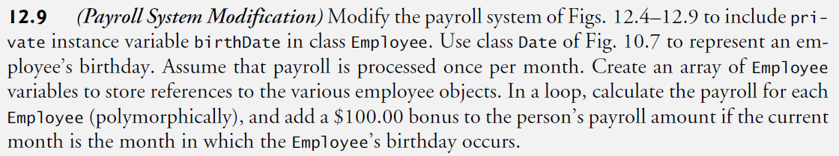

1. (Payroll SystemModification) Modify the payroll system of Figs. 12.4–12.9 to include private instance variable birthDate in class Employee.
2. Use class Date of Fig. 10.7 to represent an employee’s birthday.
3. Assume that payroll is processed once per month.
4. Create an array of Employee variables to store references to the various employee objects.
5. In a loop, calculate the payroll for each Employee (polymorphically), and add a $100.00 bonus to the person’s payroll amount if the current month is the month in which the Employee’s birthday occurs.